



APPLICATION OF THE SWANEPOEL METHOD

KEYWORDS: Swanepoel Method, Python ,İnce Film

PROJECT ADVISOR: Dr.MELTEM BABAYİĞİT CİNALİ

PROJECT MAKER: İnan Deniz TÜRK

İÇİNDEKİLER

1. Özet
2. Önsöz
3. Giriş
4. Yöntemler ve Tasarım
5. Bulgular, Tartışma ve Sonuç
6. Kaynakça
7. Ekler

1.SUMMARY

Our aim in this publication; to examine the characteristics of thin film in thin film and its applications, to mention the methods that benefit us in achieving these characteristics and to investigate these methods. The aim of this publication was to provide an approach to these desired quantities with the methods needed and the sufficient results we reached with the Swanepoel method, which is one of the useful methods for measuring the film thickness, refractive index and thickness of the thin film, which are the characteristic features of thin film. While providing this approach, meticulous work was done. The fact that the usability of the Swanepoel method was preferable and how it could be facilitated was one of the main considerations. Our research is based on the Swanepoel method and the use of this method. In order to achieve the desired results in the Swanepoel method, the wavelength and transmittance spectrum measurements, which formed the basis of the results and the measurement results made on thin film in the Swanepoel method, were to provide an adequate approach according to the measurement results and data sets created according to the results. Our main idea was to use the datasets we created with precise measurements and the desired results by using these data. Using this data, that is, the data, was very useful for this approach to create and interpret envelope graphs, which are very useful and basic in the Swanepoel method. The envelope facilitated our goals in order to achieve precise results in determining the quantities we were trying to determine. With envelope graphics The desired results have been achieved. In this publication, envelope graphs and measurement results were used to reach the information we need in using the Swanepoel Method and its use. In this publication, Python code software was used to reach the desired quantities. The graphs and analyses created are enlightening for the stages of the method that are required to be observed in the future. The automatic calculation method created provides a lot of convenience to theoretical calculations. The quantities sought with the Python program written have been reached.

2. GİRİŞ

Thin films, thicknesses from a few nanometers (nm) to a few micrometers ((m) Thin-film from a fraction of a nanometer to a fraction of a nanometer. with a thickness ranging from several micrometers to the surface of a substrate, or It is a layer of material deposited on top of another film[2]. Metals A variety of products, including ceramics, polymers, and semiconductors they can be made of materials[3]. Thin films, typically each for different materials and types of applications It is produced by various deposition techniques that are suitable. The choice of method of film It depends on the desired properties, substrate (substrate) and cost considerations. The main thin film production techniques include PVD (physical vapor deposition), CVD (Chemical Vapor Deposition), Electroplating, Sol-Gel Process. is[4].By selecting one of the thin film techniques, thin film substrate During the production phase, the environment should be clean for few errors. [4] Reference: Kessler, M. (2012). Thin Film Deposition: Principles and Practice. Springer. To define specific structures on the film, thermal annealing, UV curing or It can be subjected to various processes such as giving more patterns. Characterization thickness, optical properties and structural integrity of the film Using techniques such as spectroscopy, microscopy and electrical testing, the cap- It is evaluated (produced) as Damascus[3]. The best in calculating film thickness and refractive index with the Swanepoel method, the most It is one of the correct and far-reaching techniques. With the Swanepoel method, the optical properties of thin film can be reached[1]. Thin film by Swanepoel method Extinction coefficient information can also be accessed[1]. Reflection on this information, or It can be reached through the analysis of interference patterns in the permeability spectrum. The Swanepoel method allows thin films to be used for a wide variety of materials and light sources. It is used to determine its optical properties[5]. The choice of thin film (material) and light source is important for the analysis [6]. Let's briefly summarize the choice of materials. Thin films of various materials can be analyzed by the Swanepoel method. Semiconductor materials (eg: silicon, gallium arsenide), dielectric materials (silicon dioxide, titanium dioxide), metallic films (silver), organic materials (polymers, organic semiconductors) can be examined, including but not limited to.

The choice of material and light source significantly affects the accuracy of the Swanepoel method. The optical properties of the material and the wavelength of the light source must be carefully selected to ensure precise measurement of interference fringes in the transmission spectrum. The Swanepoel method typically uses the optical property under study. A wide spectrum of wavelengths that covers the range of interest for requires a light source[6]. Common light sources used include: White light sources, these are in the visible region and in the near-infrared (NIR) range, It provides a continuous spectrum of wavelengths. Tunable lasers:These lasers emitting beams of specific wavelengths within a customizable range It allows precise control over the measurement conditions. Selection of light source the spectral range required for the range, the availability of the equipment and the experimental It depends on factors such as restrictions. The experimental board, the experimental setup for this method, is typically a certain angle of incidence of light on the experimental specimen. and measurement of the reflection or transmittance spectrum. Contains. In order to make accurate measurements, the angle of incidence, polarization of the light Attention is paid to factors such as its condition and the optical components used in the installation When selecting materials for thin-film analysis, it is important to consider the transparency of the material and its compatibility with the deposition method. To obtain accurate measurements, the light source must have a stable and well-defined wavelength range that matches the optical absorption properties of the material[7]. The beam of the light source used in the Swanepoel method must be a parallel directed monochromatic light beam. In order for the Swanepoel method to accurately determine the optical properties of thin films, the light source must produce both a parallel and a monochromatic beam. A parallel beam ensures that the light waves remain parallel over the measuring distance, reducing errors caused by beam divergence. Monochromatic light or monochromatic light beam refers to light that consists of a single wavelength or frequency. A monochromatic beam allows light to consist of a single wavelength; This is necessary for precise interference measurements. [8,9]

The monochromator uses certain wavelengths to pass through the film in a specific order. allows for detailed analysis of how the film affects light of each wavelength [1,9,10]. This setup is important for the Swanepoel method to accurately determine the refractive index and thickness of the film by analyzing the position and nature of the interference fringes in the transmission spectrum. [8] The light passing through the film is measured with a spectrometer. This device captures the intensity of light at various wavelengths and creates interference models (maximum and minimum points). This is the maximum and Their position in the spectrum of the minimis is related to the optical thickness of the film (the refractive index of the film multiplied by the physical thickness). Analyze these formulas and applying Swanepoel's formulas, the refractive index and thickness can be determined [5]. This method is very effective for transparent (permeable) and semi-transparent (semi-permeable) films where interference effects are significant and measurable. Optics are particularly valuable for films used in applications with precise control over them. Selection of halogen or xenon lamps; Stable output and wide emission range It is especially useful due to. It allows accurate and detailed analysis of the optical properties of thin films over a wide spectral range. These resources are, A wide range of waves, from ultraviolet to visible and near-infrared They were chosen because they emit light. This wide range is necessary to achieve a comprehensive transmission spectrum of the thin film. [10] A broadband light source is frequently used to precisely characterize thin films over a wide spectral range. Halogen and xenon lamps are common choices because they emit a continuous spectrum of light. When paired with a monochromator, these broadband sources can selectively filter light to produce a monochromatic beam of specific wavelengths. This setup allows for precise measurements of the optical properties of the film at different wavelengths, allowing for comprehensive characterization. [1,7,10] The Swanepoel method is an effective method in terms of calculating the thickness (t) and complex refractive index (n = n – ik) of the thin film with the rays sent by the appropriate light or beam source on the thin film. The Swanepoel method is one of the most accurate methods for calculating the film thickness (t) and complex refractive index (n) of the measured permeability spectra of a film from the envelopes (T(M) and lower T(m) envelopes (T maximum and T(minimum))[11]. The Swanepoel Method has been found to be satisfactory in the range of interference fringes, that is, in T(M) and T(m) positions, and is preferred with this information. This is why the calculation points are limited, and the number of points depends on the thickness of the film, which affects the calculation accuracy.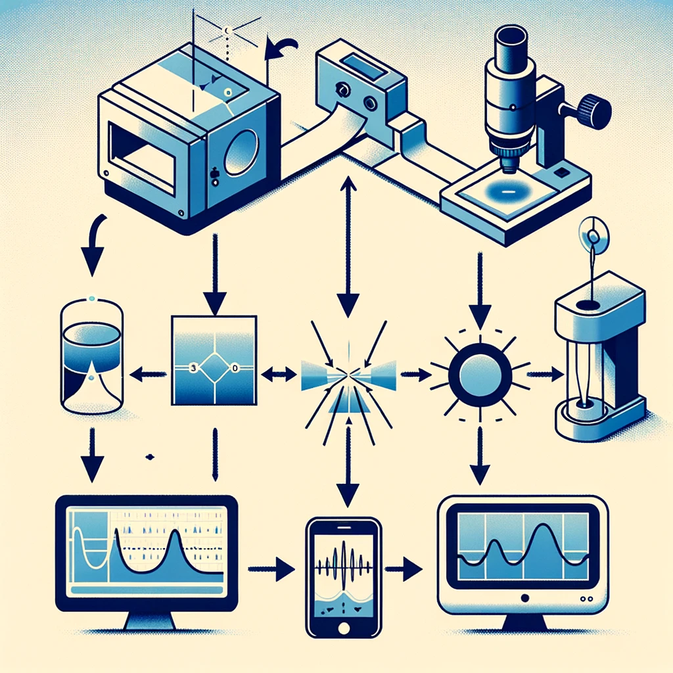

Şekil -

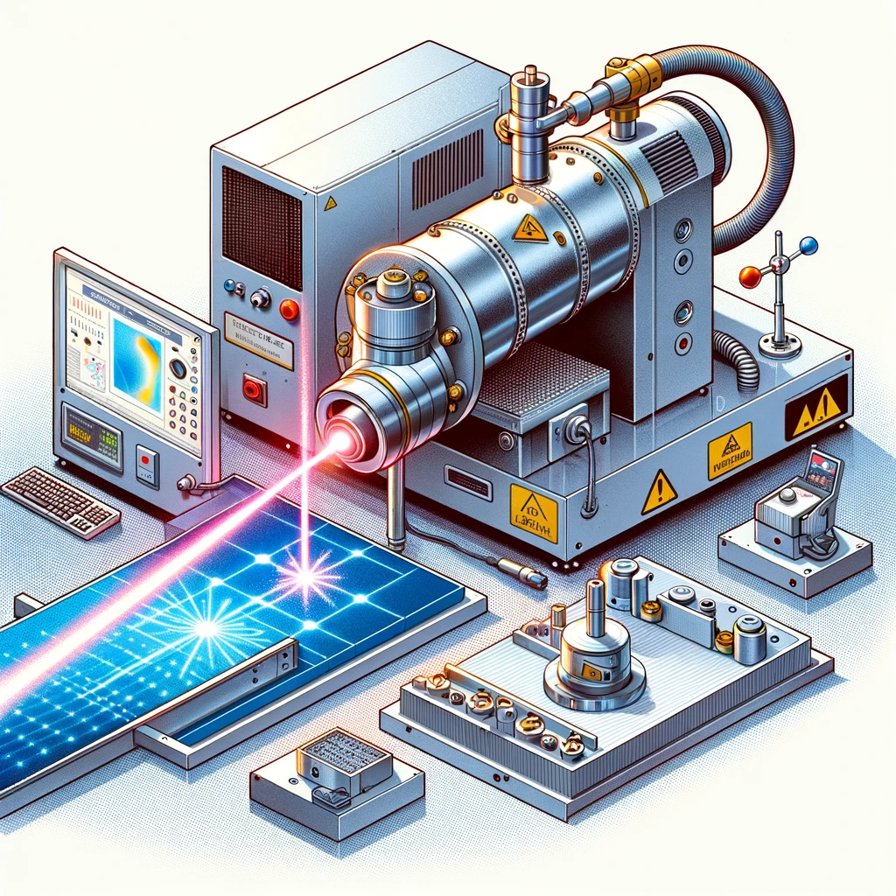

Şekil-

In the context of thin films, in particular, optical properties such as the Swanepoel method and When discussing methods of analysis, the term "envelope" refers to the fact that thin films are conduction or maximum and minimum values of an interference model in the reflection spectrum refers to the boundary curves that describe [1,6]. These envelopes are optical of the film It is critical in determining its constants and thickness[5]. Thin Understanding the Envelope in Film Applications, Interference Patterns: Light with a thin film When interacting, it causes multiple reflections and transmissions on movie interfaces. is exposed[7]. This creates an interference pattern due to the constructive and destructive interference of light waves[11]. 11- Pedrotti, F. L., Pedrotti, L. M., & Pedrotti, L. S. (2007). Introduction to Optics (3rd ed.). Pearson. Envelope Curves: The interference pattern is typically defined as maximum and minimum values oscillates between. The upper envelope curve connects the peaks (maximums) of the interference fringes, while the lower envelope curve pits (minima) binds to each other. [5] Swanepoel Method: This method is used to calculate the refractive index and thickness of the thin film transmission It uses the envelope curves of the spectrum. Positions of maximums and minimums, and These optical properties can be obtained by analysing their intensity[5]. Thickness Measurement: The distinction between consecutive maximums or minimums (eaves spacing), It is related to film thickness and refractive index. Using the envelope method, compute by focusing on endpoints rather than each point in the interference pattern simplifies[1]. How it works: Transmission Measurement: Using a spectrophotometer measure the transmission spectrum of the thin film across various wavelengths[6]. Identify Extremes: Make sure that the maximums and minimums in the transmission spectrum Determine their location[5]. Draw Adverbs: Their maxima and minimum, respectively Draw the top and bottom envelopes by combining[1]. Analysis: Determine the Refractive Index: Use envelope curves to calculate the effective refractive index at different wavelengths[1]. Calculation of Thickness: Use the periodicity and refractive index information of the interference fringes to determine the film thickness{6]. Meaning of Adverb: In a general sense, an "adverb" refers to a curve that debounds another curve or set of curves. In thin-film analysis, envelope curves provide a simplified representation of the oscillating interference model, facilitating the extraction of meaningful physical properties such as thickness and refractive index [1,5]. Visualization: Upper Envelope: The curve that passes through the peaks of the transmission or reflection spectrum. Lower Envelope: The curve that passes through the valleys of the transmission or reflection spectrum. The envelope method is especially useful in optical characterization because it allows detailed interference models to It reduces the complexity of analysis and makes thin-film properties simpler and allows it to be accurately determined[6].

IV. METHODS AND DESIGN

In this section; Swanepoel method of thin film desired Quantities include measuring the thickness of the thin film and the coefficient of refraction. The measurement and representation of the desired quantities has been tried to be facilitated with the Python Software program. In the context of thin films, especially when discussing optical properties and analysis methods such as the Swanepoel method, the term "envelope" refers to boundary curves that describe the maximum and minimum values of an interference model in the transmission or reflection spectrum of thin films.



Figure 1. Simulated transmission spectrum (full curve) for a 1pm a-Si:H film on a finite glass substrate. T(m),T(M),T((),T(i)curves by text Such as refractive index, transmission spectrum and thickness of thin films quantifications are more comfortable and more reliable with the Swanepoel method It is thought that it will be reached. Approach to the problem covered in this chapter and its results We aimed to reach it with the help of codes written with Python program. Transmission and wavelength graphs were drawn. From the drawn envelope chart The refractive indices calculated as a result of our utilization were also graphed. While discussing optical properties and analysis methods such as the Swanepoel method The term "envelope" refers to an interference in the transmission or reflection spectrum of thin films Expression boundary curves that define the maximum and minimum values of the model It does. These envelopes are used to determine the optical constants and thickness of the film It is critical.

R_max = ⏐(n_0 – n2 / n_s) / (n_0 + n2 / n_s)⏐ Equation (1)

n = ε_1 + ( (ε_1)2  - ((n_o).(n_s))2)1/2 Equation (2)

ε_1 = ((n_0)2 + (n_s)2)/2 + 2.(n_o).(n_s).(T_max- T_min)/T_max.T_min (3)

d = (λ_1).(λ_2)/(n(λ_2). λ_1 – n(λ_1). λ_2) Equation (4)

When the values of the refractive index are known at wavelengths of two consecutive maximum (T_max) or minimum (T_min) values of spectral transmittance, the film thickness is given by d(4).

|  |  |
| --- | --- |
| Lambda (nm) | Transmission |
| 300 | 0,40244 |
| 301 | 0,42705 |
| 302 | 0,453 |
| 303 | 0,48035 |
| 304 | 0,50917 |
| 305 | 0,53189 |
| 306 | 0,55532 |
| 307 | 0,57963 |
| 308 | 0,60485 |
| 309 | 0,62701 |
| 310 | 0,64498 |

Table-1

This table shares a small portion of the wavelength vs transmission values measured. With the data obtained as a result of the experiment, the transmission graph corresponding to the wavelength (wavelength) was drawn (plotted) with Python code. Peak and trough points are again with commands called from the Python library It was determined as shown in Figure 2. The determined maximum and minimum (peak and trough) points were determined with the help of Python code Figure-2 Code-1.i (The determined maximum and minimum points were shown in the plotted graph (Figure-3).

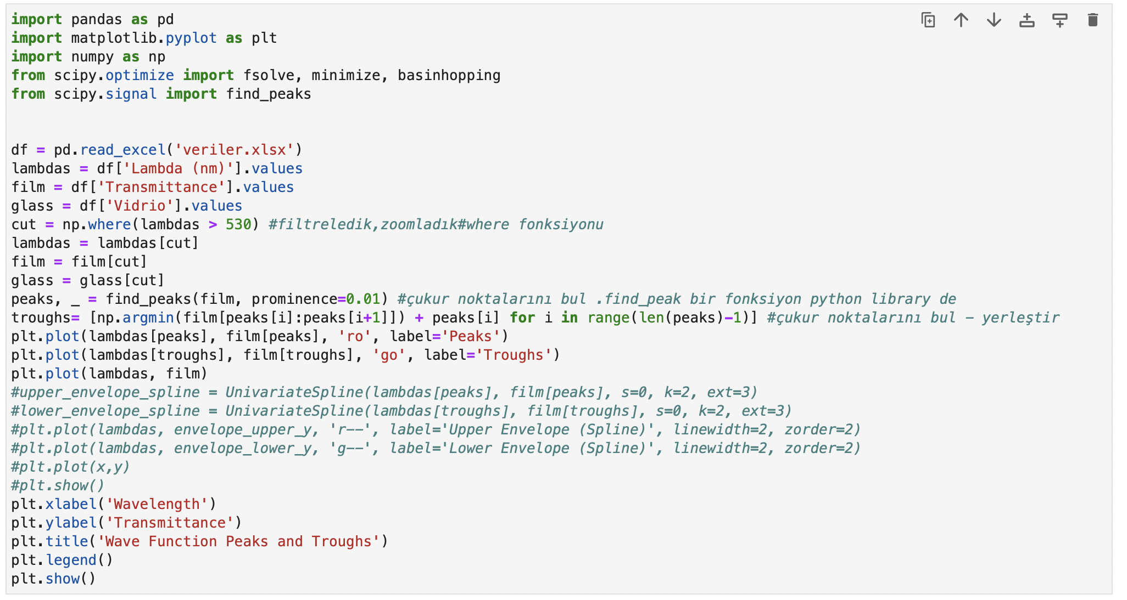

Figure 2 – Code 1

Determination of peaks and troughs using our determined data set

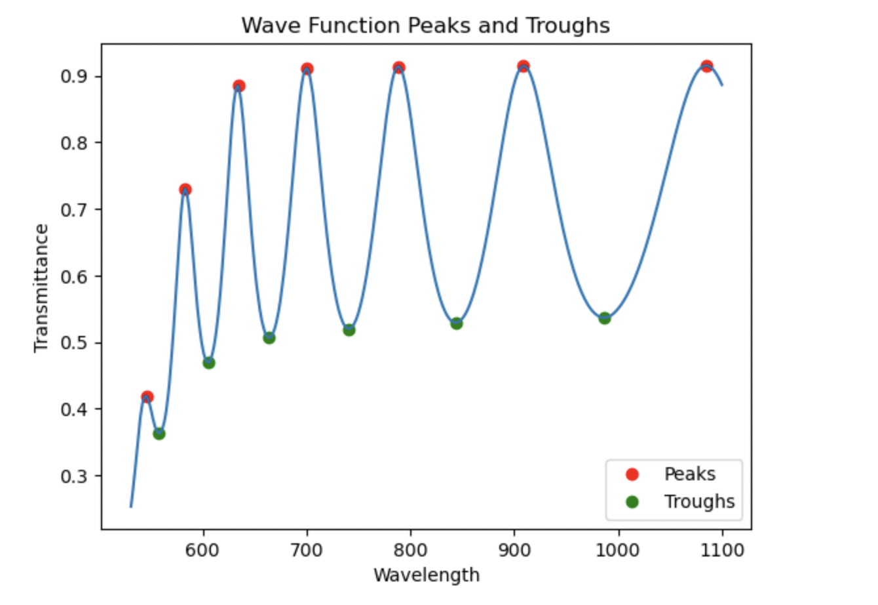

Figure-3. Graphical representation of wavelength transmission spectrum relationship.

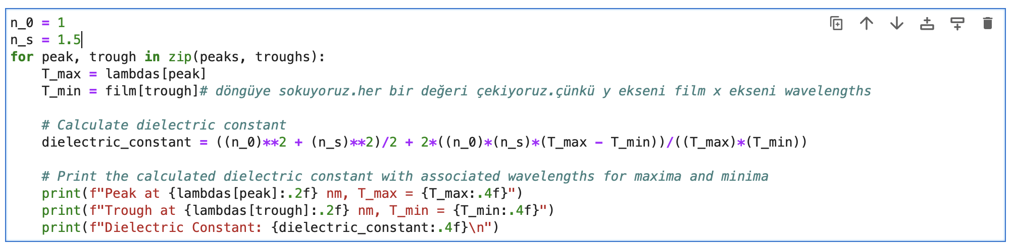

Şekil 4 – Kod 2

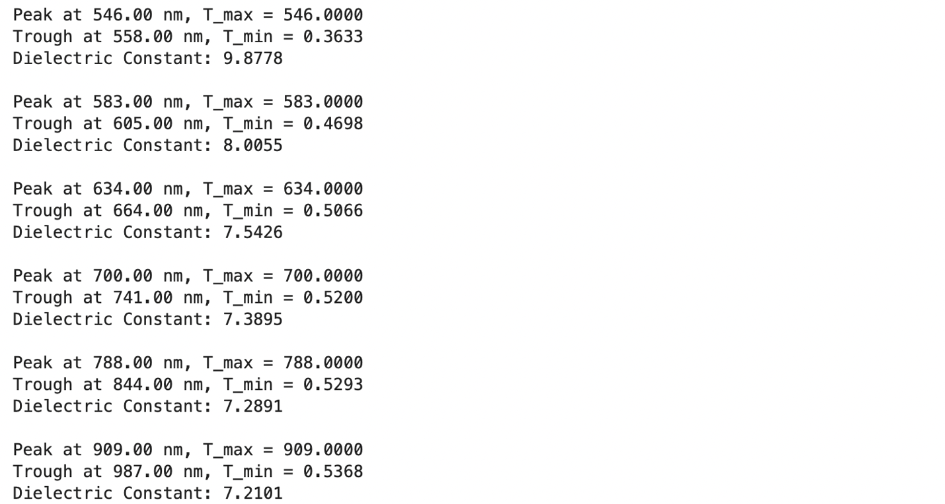

Figure 4a

The output of the code written in Figure 4. The dielectric constant calculated in our first stage made it easy for us to find the refractive index in the next stage. Let's continue to go step by step.

Using Eq. 2, the refractive indices were calculated by means of code.

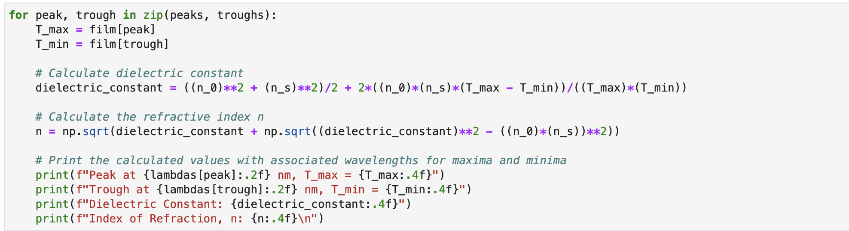

Figure 5 – Code 3

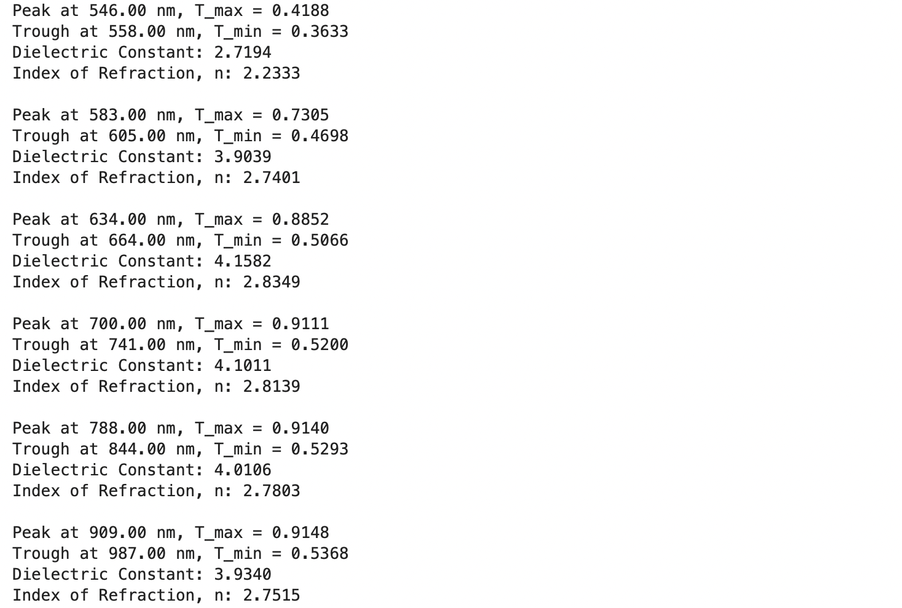

Figure 5a – Output(s) of Code 3

The dielectric constant calculated in our first stage made it easy for us to find the refractive index(es) in the next stage.

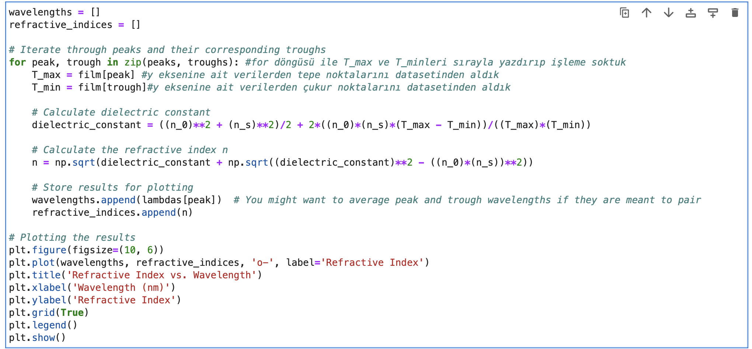

Figure 6 – Code 4

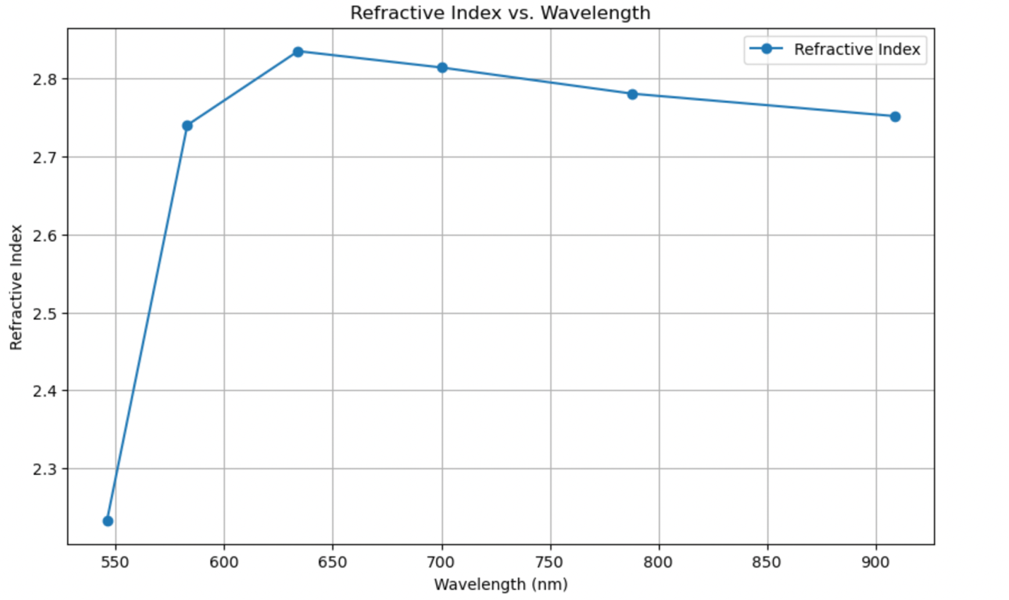

Figure 6-a Code 5

The output of Code 4. Refractive index wavelength graph in discrete spectrum It was plotted. f(wavelength) discrete spectrum display

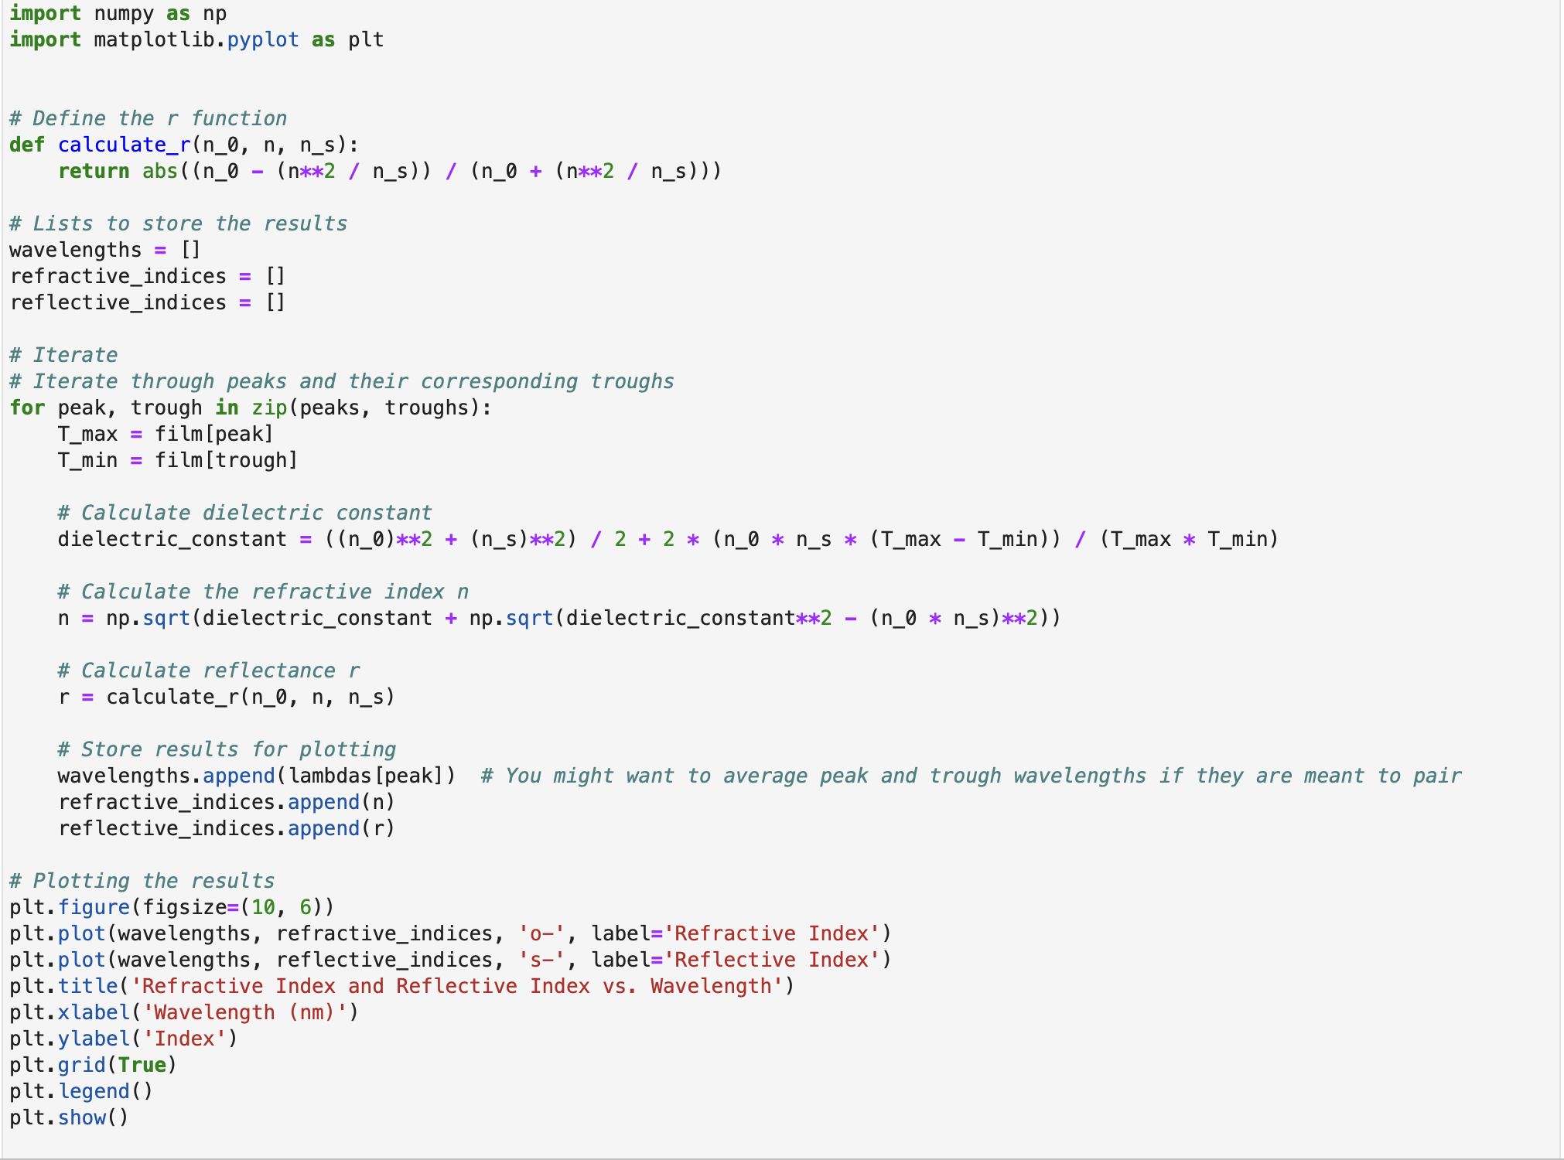

Figure 7- Code 6

In addition, reflectance was calculated.

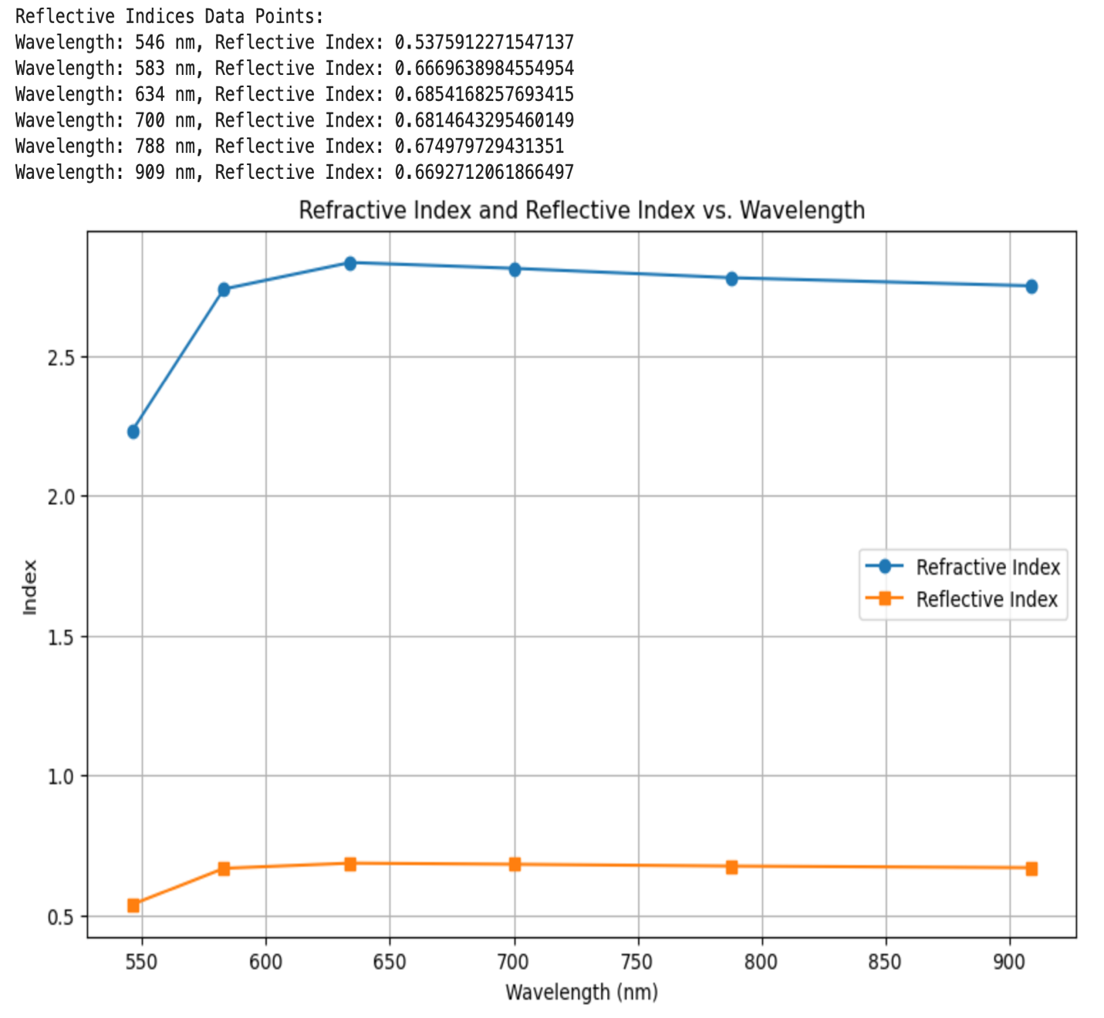

Figure 7a Figure 7 - Output of Code 6

The graph of both refractive index and reflectance against wavelength was plotted.

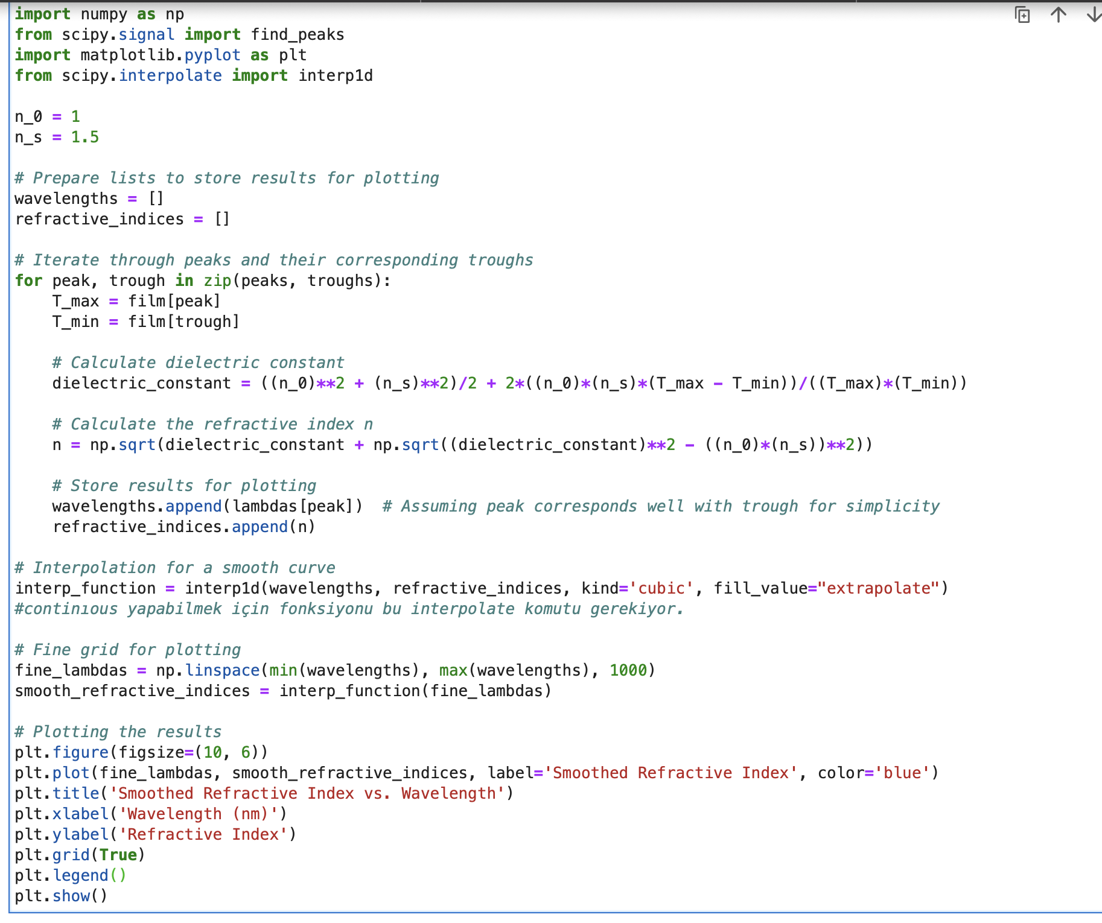 Figure 8 – Code 7

Our function is called in python by entering the interpolation process with the "interp1d" command A continuous graph and spectrum of points within the boundaries were obtained.

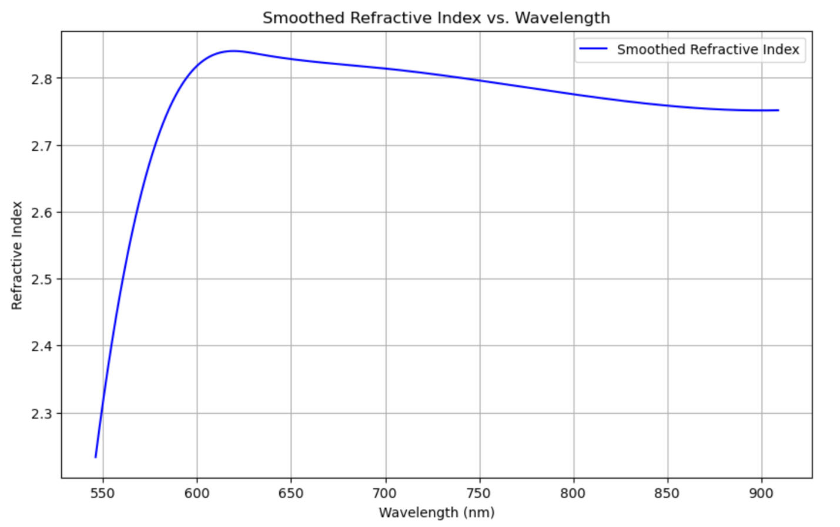

Figure 8a- Code 7a

Plotted refractive constant of Figure 8 in the written program -wavelength graph (continuous spectrum display) In a general sense, an "envelope" refers to a curve that bounds another curve or set of curves.

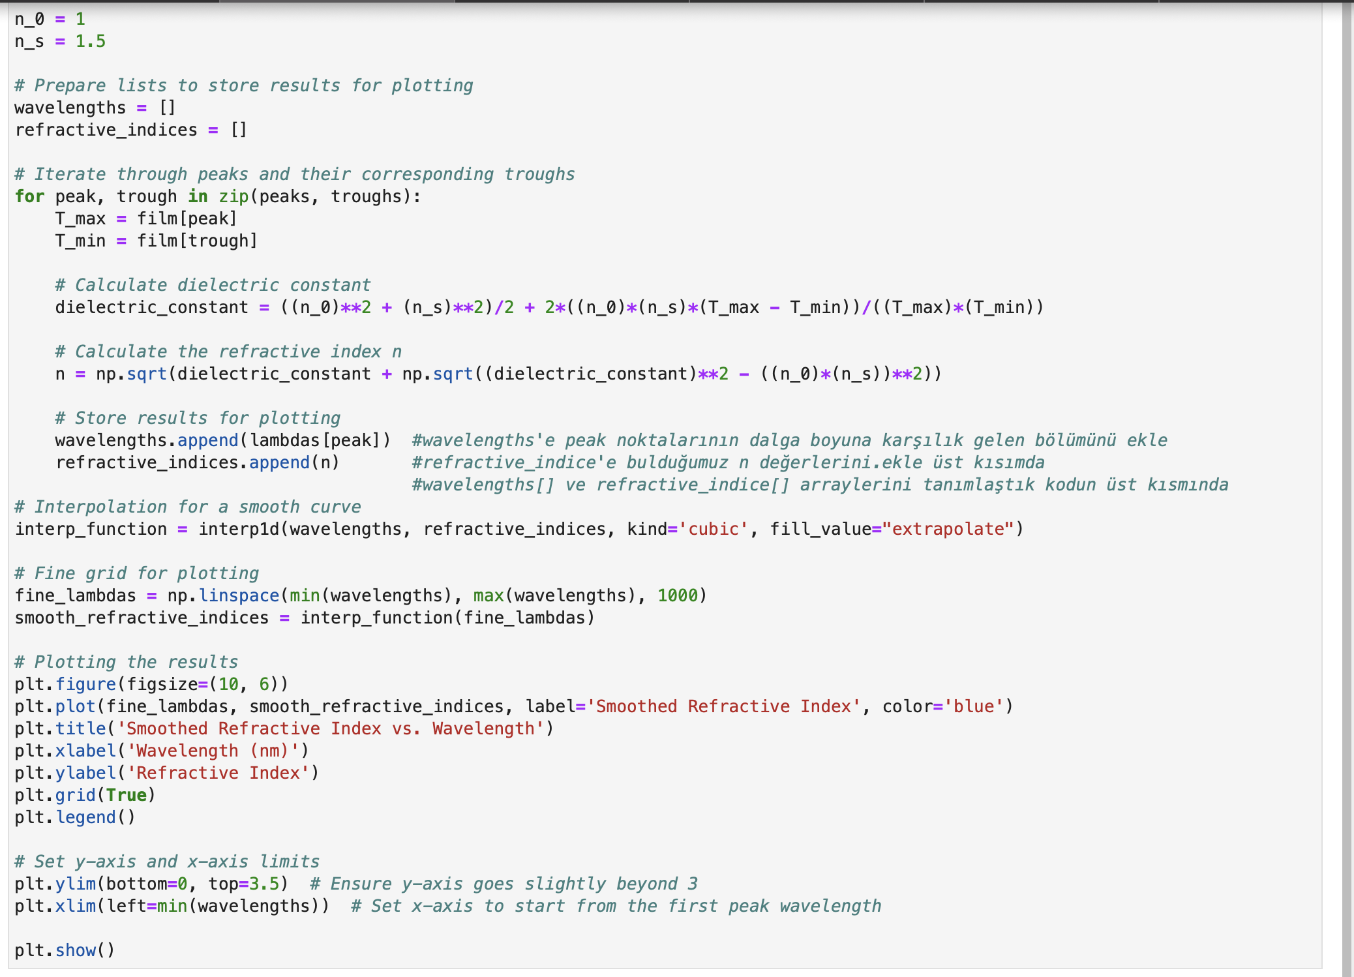

Figure 9 - Code 8

Figure 8a- In addition to the software specified in Code 7, we started the y column (axis) from 0 and finished at 3.5. This process will give us our chart

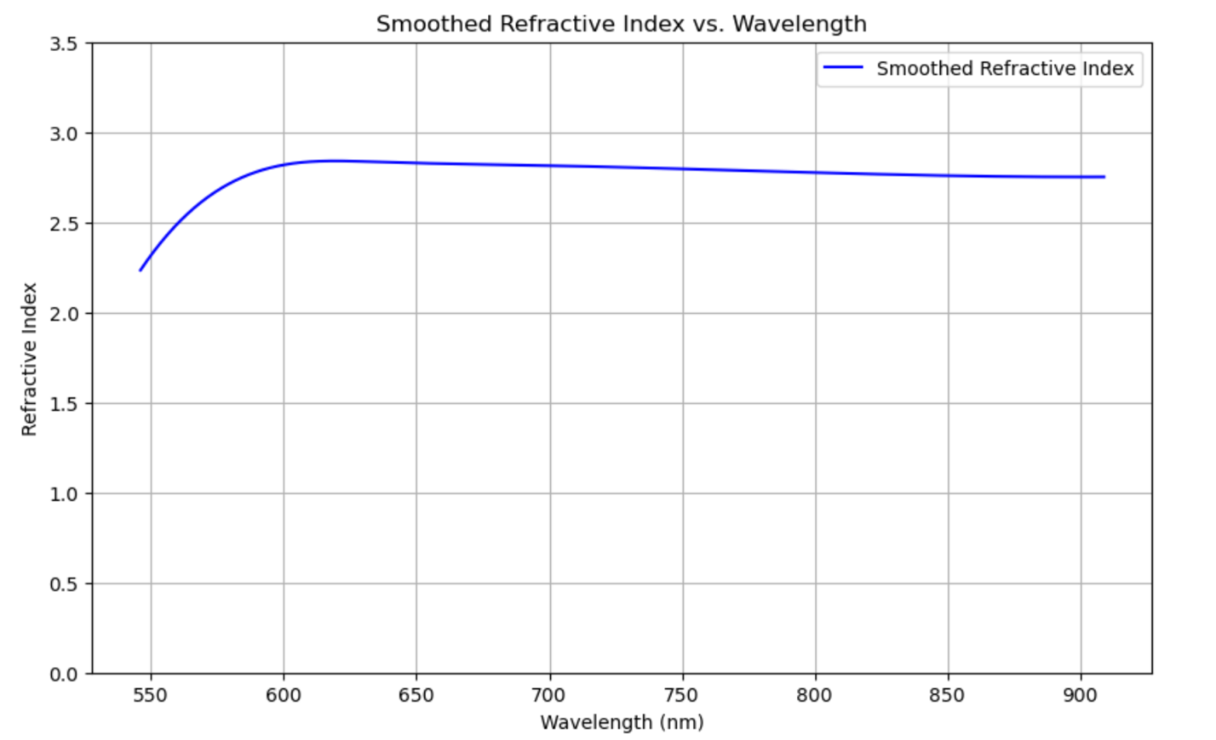

Figure 9a

Output of Code 8. In addition to the software specified in Code 7 in our chart, which we created with our plot command, we started the y column (axis) from 0 and finished it at 3.5. This process allowed us to look at our graph

from a distance from our point of view.

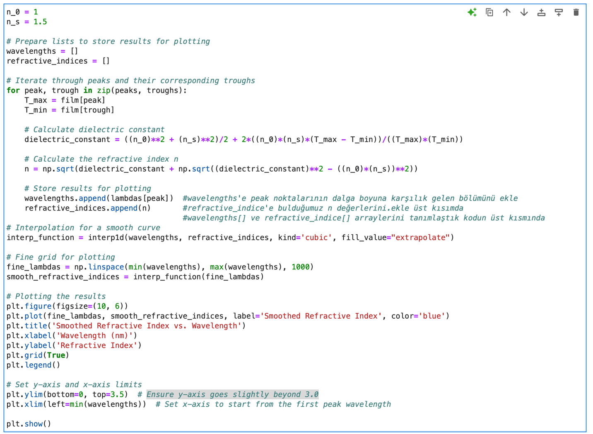

Figure 10 – Code 9

We shifted the wavelengths axis of the X-axis to the minimum wavelength starting point.

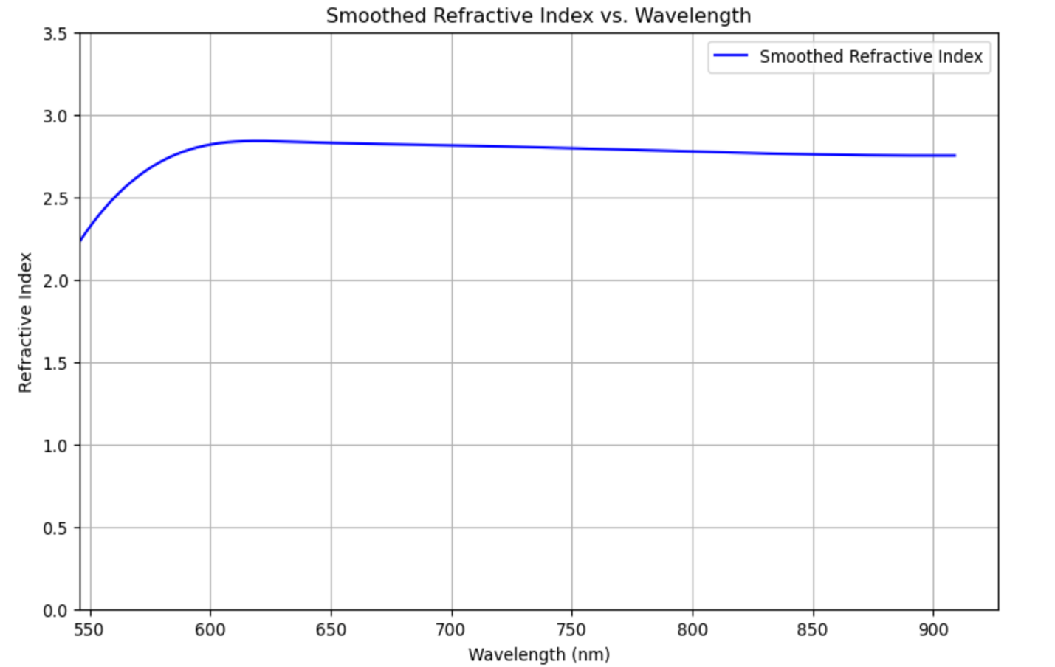

Figure 10a – Code 9

Output of Figure 10. Shifted chart.

My goal is to prepare a presentation that shows moving changes, such as animation.

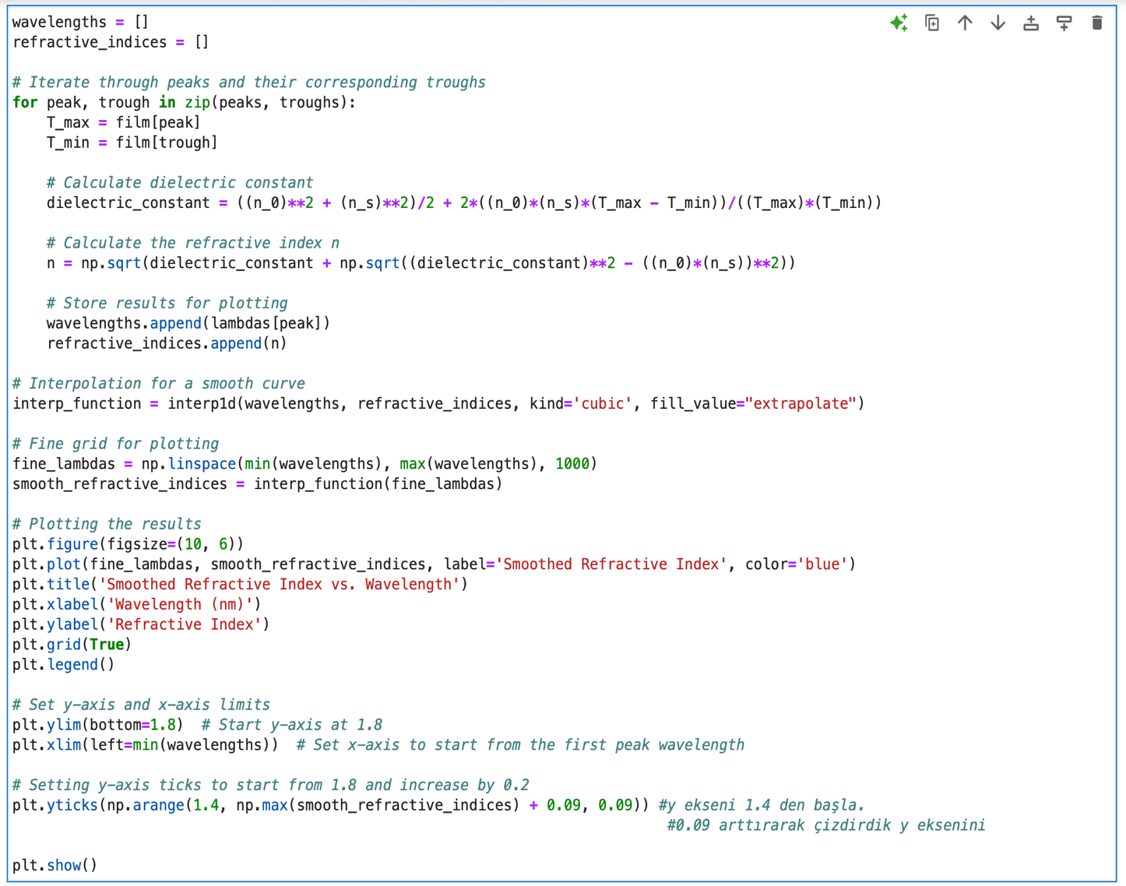

Figure 11 – Code 10

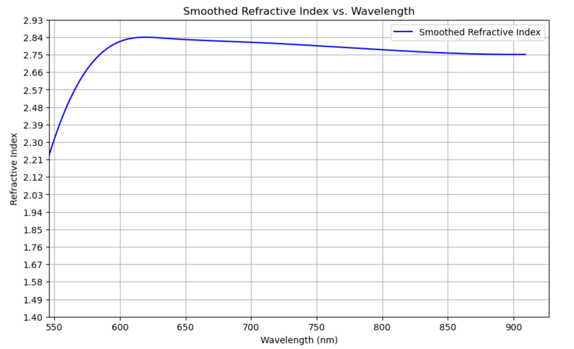

Figure 10 - Code 10 output

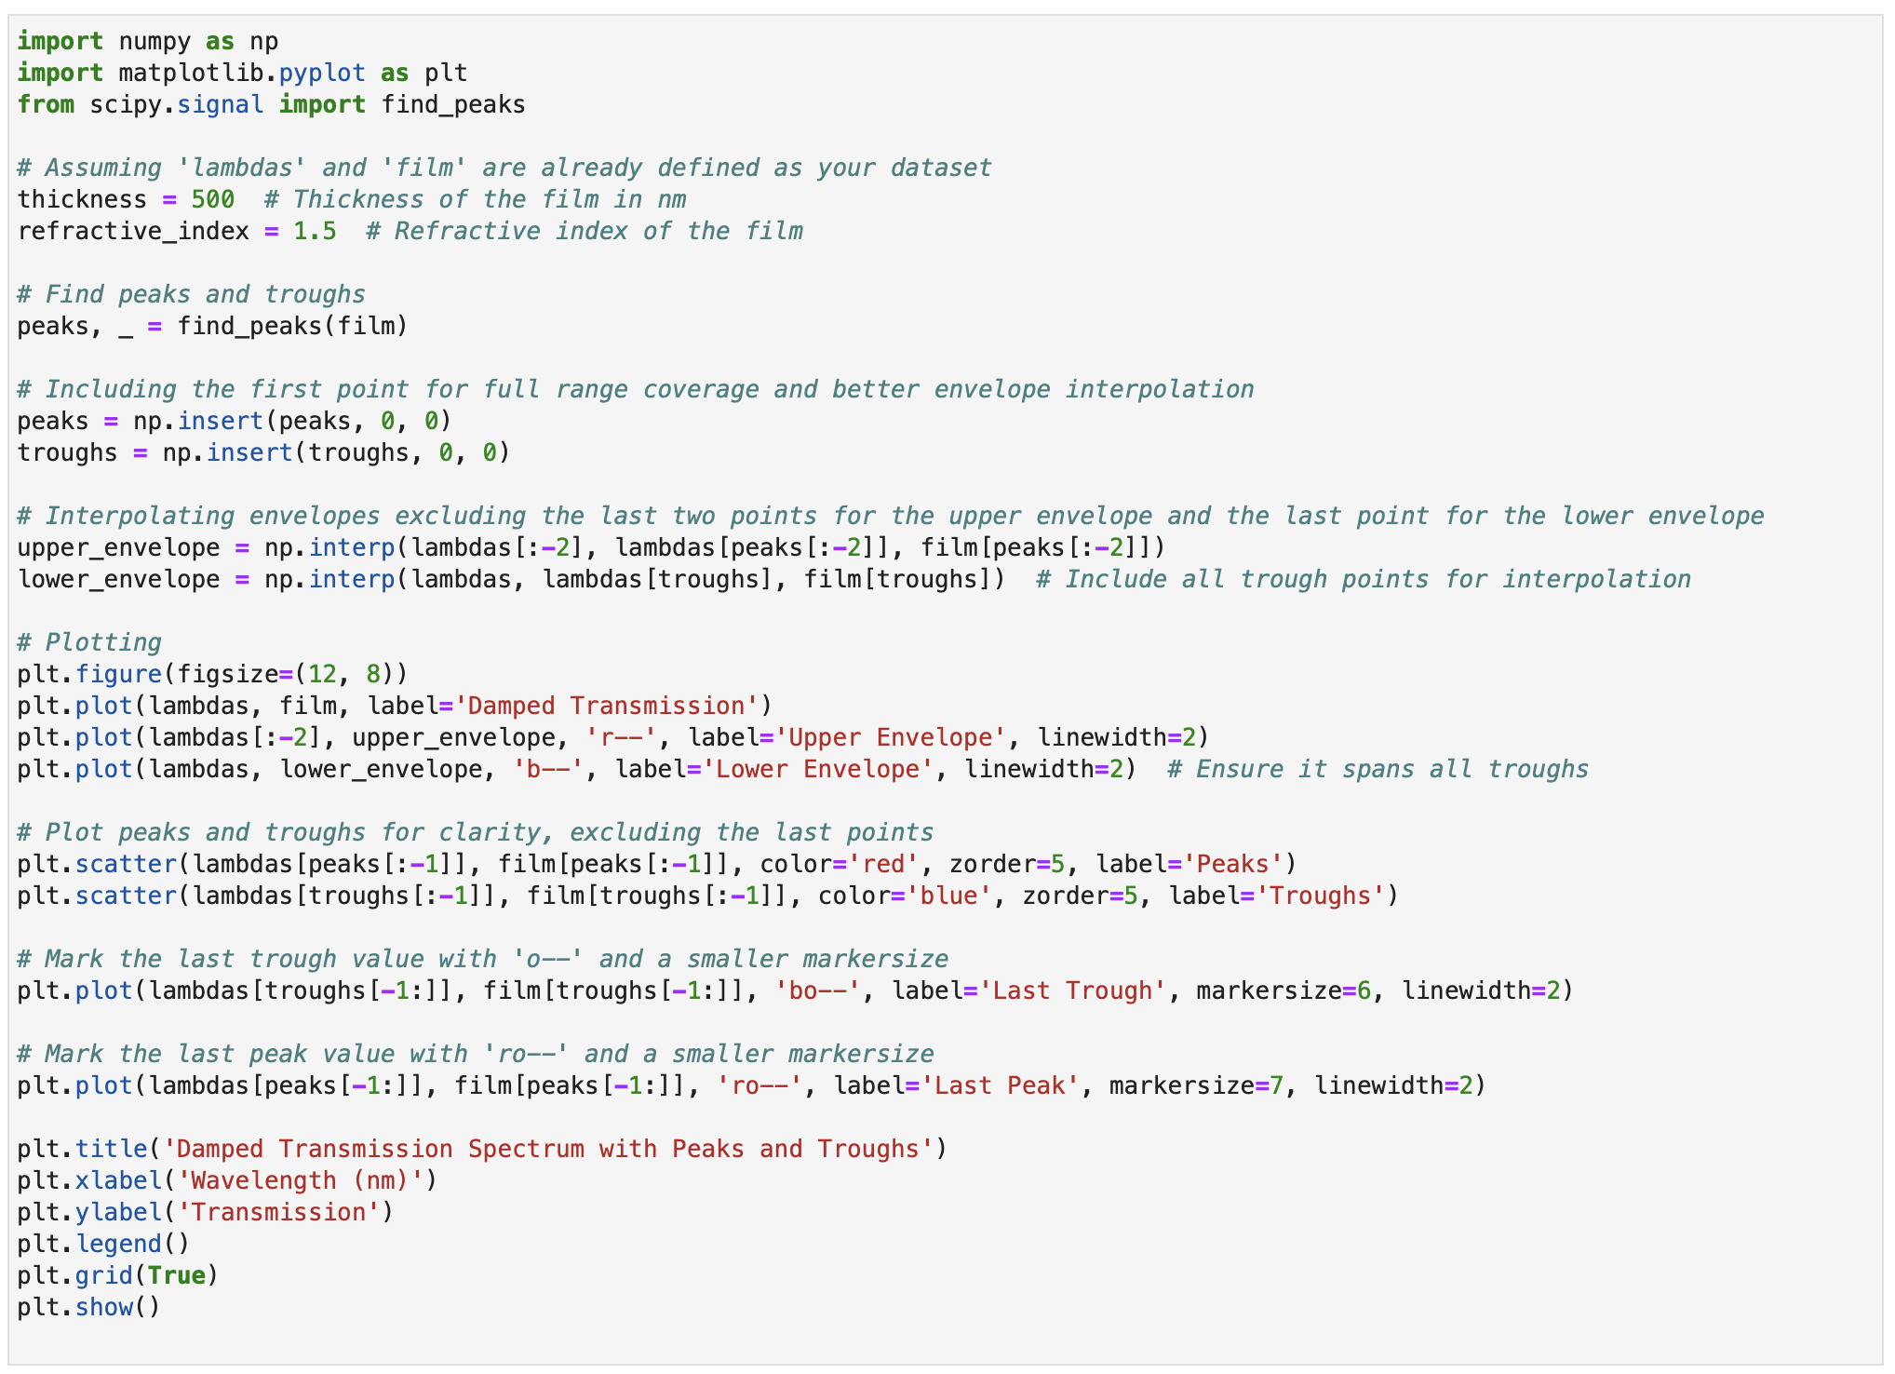

Figure 11- Code11

The code written to draw an envelope graph.

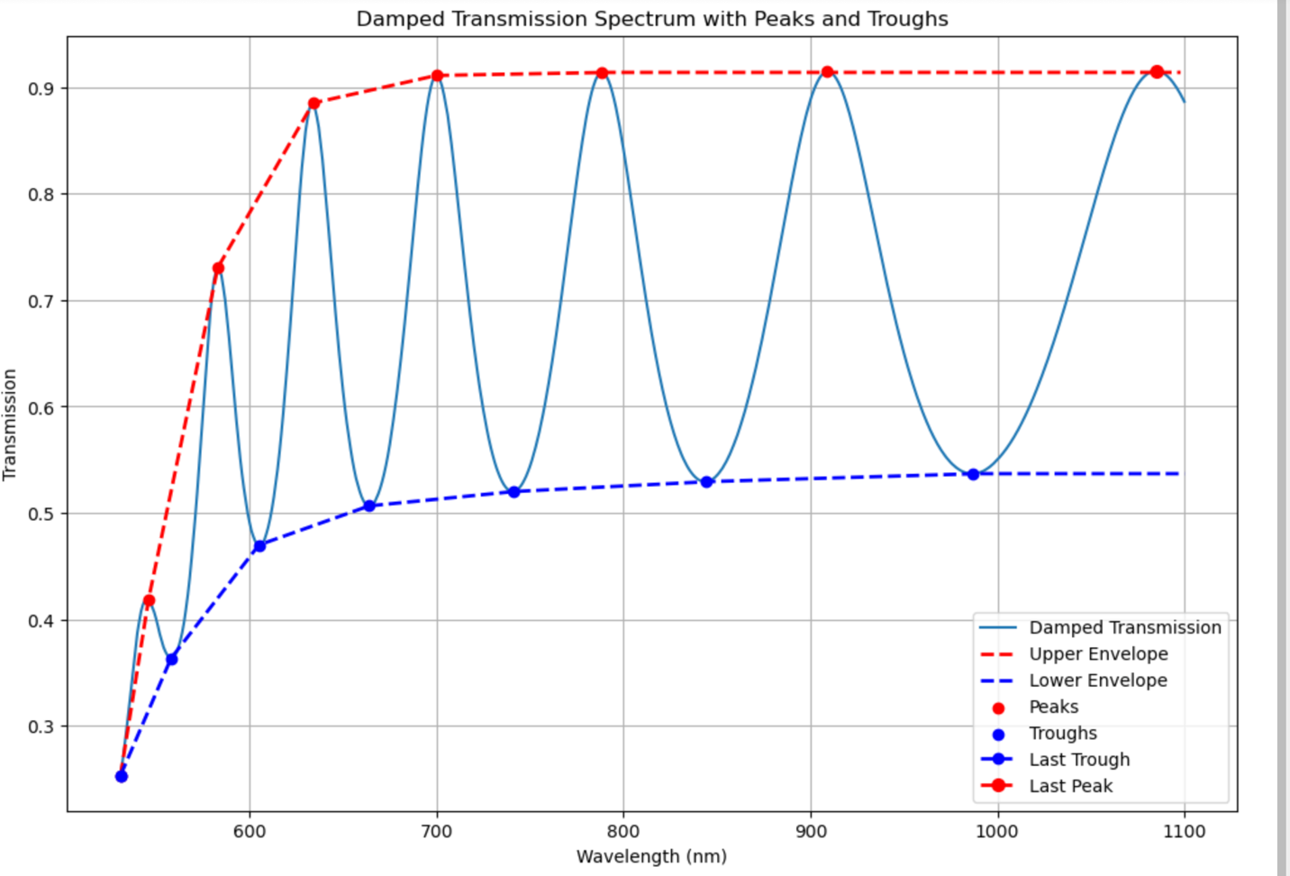

Figure 11a - Output of Code 11 –

Discrete spectrum: Passing through maximum and minimum points (peaks and peaks) The curves are shown in different colors. The region between the interior and the area between these boundary curves represents the envelope.

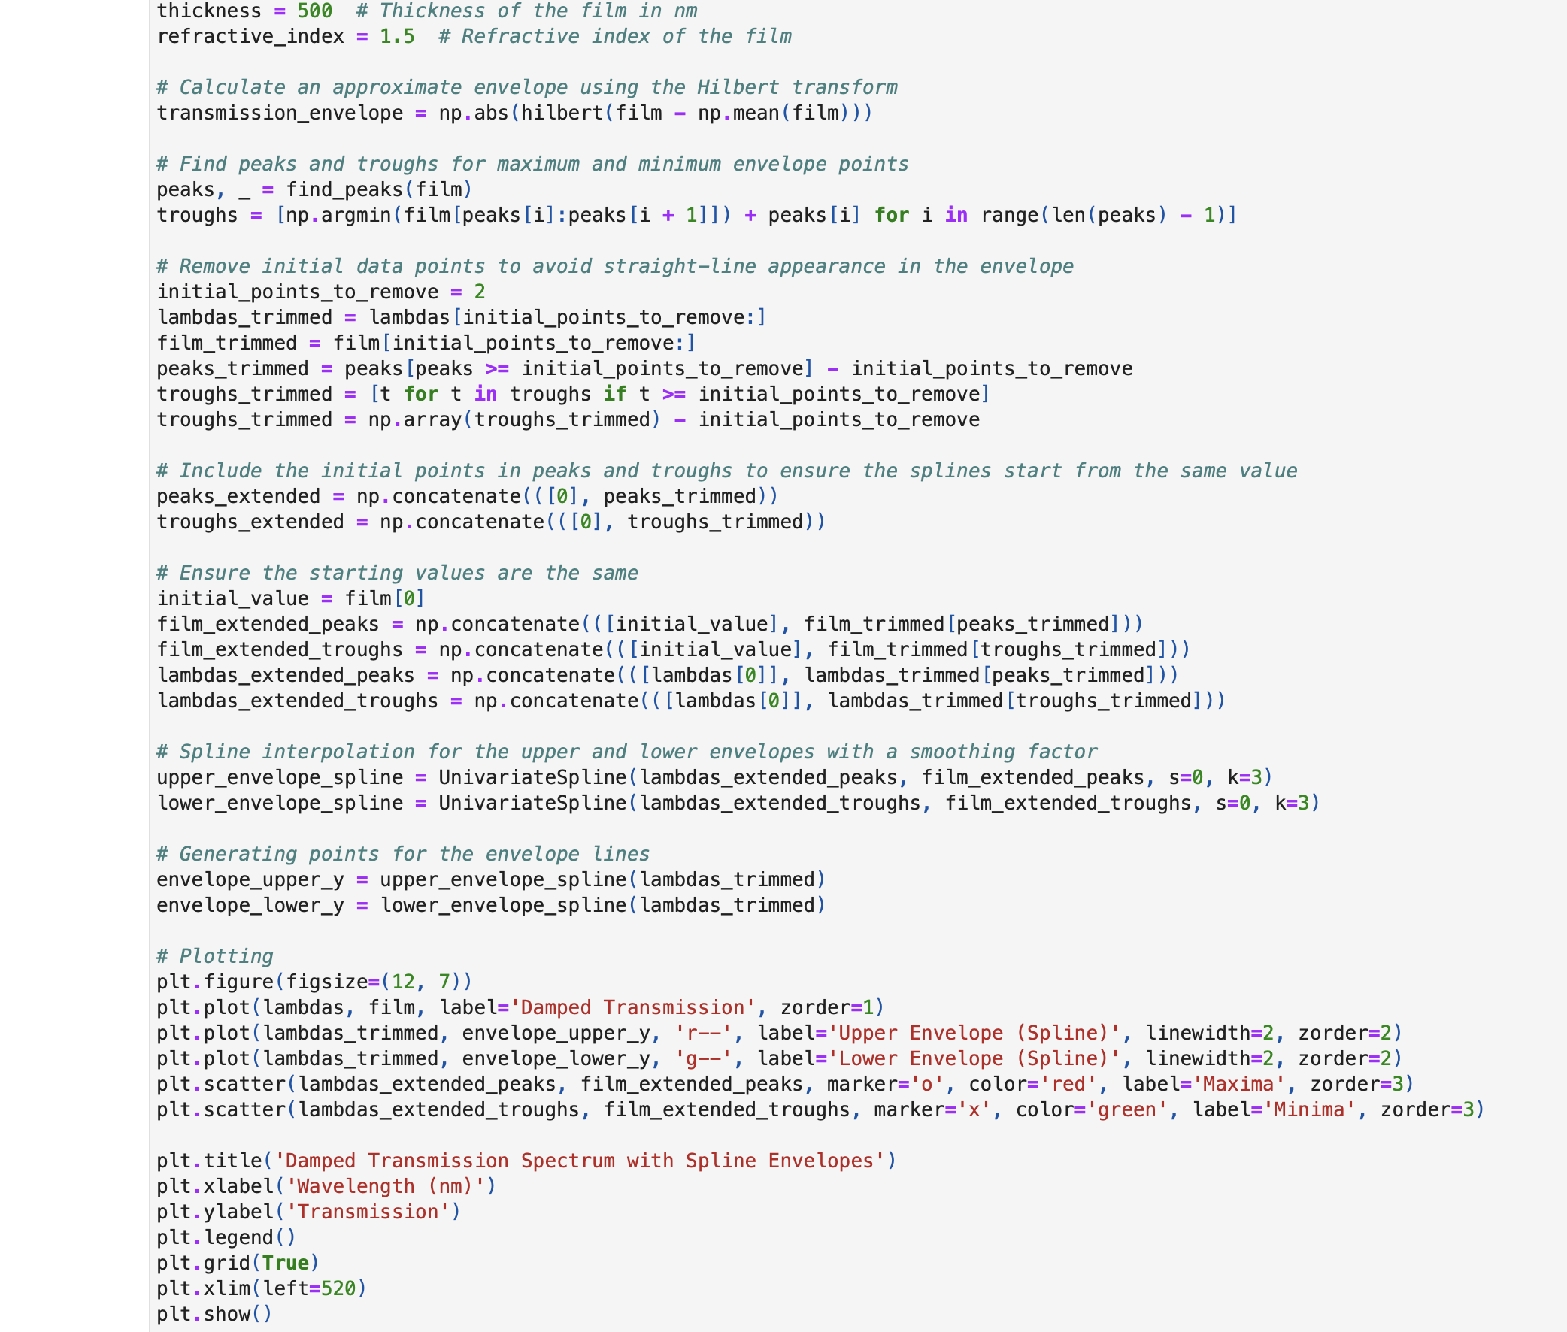

Figure 12- code 12

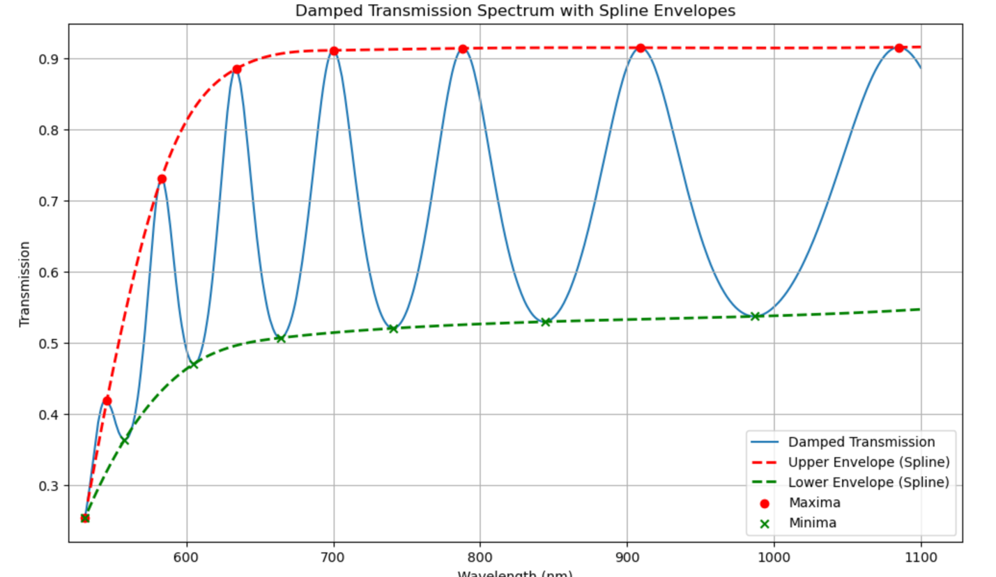

Figure 12a – Output of Code12

Continuous envelope chart

Meaning of Envelope: In a general sense, an "adverb" refers to a curve that debounds another curve or set of curves. In thin-film analysis, envelope curves provide a simplified representation of the oscillating interference model, making it easier to infer meaningful physical properties such as thickness and refractive index.

5. Results, discussion and conclusion Using the simulated transmission spectrum for a 1.1 (m a-Si:H film on a conductive finite glass substrate, my result was 18% inaccurate. The thickness was found to be approximately 18% error. I did a lot of experimentation to create the quantities I wanted to achieve in the Python code I created. As a result of the code and working principles I was able to create as a result of these experiments, I realized and observed that the more data points I had, the closer the graphs and results I got. Even if the total number of peaks and troughs is small, I divided the total data point according to the range of minimum trough values and maximum peaks, including peaks and troughs, step by step, since it covers all boundaries due to general envelope logic. For example, in the drawn graph, there are n peaks and troughs. I have divided these n peaks and troughs, that is, the value ranges that determine our graph in the boundaries determined by the peaks and trough, into N steps in order to achieve the desired results. The number value of N is very high. For example: N = 800 ,800 data points and we want to see even the slightest fluctuation in our chart. As a result of our graph, which was drawn relative to the small number of total peaks and troughs, we saw that even if we divide it into approximately 800 equal parts (let's say about 400 maximum and 400 minimum) at each 800 data points, it gives the same result, that is, the approximate result. When I divided the number of peaks and troughs into 800 ranges that I wanted relative to the small number of total data points, the results I found were very low with a very small margin of error.

6. BIBLIOGRAPHY

[1] Heavens, O. S. (1991). Optical Properties of Thin Solid Films. Dover Publications.

[2] Smith, D. L. (1995). Thin-Film Deposition: Principles and Practice. McGraw-Hill.

[3] Reference: Ohring, M. (2001). Materials Science of Thin Films. Academic Press.

[4]Reference: Kessler, M. (2012). Thin Film Deposition: Principles and Practice. Springer.

[5] Swanepoel, R. (1983). "Determination of the thickness and optical constants of amorphous silicon." Journal of Physics E: Scientific Instruments, 16(12), 1214-1218.

[6] MacLeod, H. A. (2010). Thin-Film Optical Filters. CRC Press.

[7] Born, M., & Wolf, E. (1999). Principles of Optics. Cambridge University Press.

[8] Demtröder, W. (2003). Laser Spectroscopy: Basic Concepts and Instrumentation. Springer.

[9] Reference: Hecht, E. (2002). Optics. Addison-Wesley.

[10] Yariv, A. (1989). Quantum Electronics. Wiley.

[11] Pedrotti, F. L., Pedrotti, L. M., & Pedrotti, L. S. (2007).

Introduction to Optics (3rd ed.). Pearson.